To Whom it May Concern,

Your company has been identified as a Department of Natural Resources and Conservation (DNRC) contract holder registered as a Profile 1 vendor. DNRC will be sending Profile 1 contract holders a registration invitation via email. To complete your vendor registration in eMACS, follow the instructions provided below.

eMACS and Vendor Registration Invitation

Montana Acquisition and Contracting System or eMACS, is the eProcurement software solution utilized by State of Montana agencies that provides vendor management services, bid and procurement processes, and contract management tools.

The Department of Natural Resources and Conservation (DNRC) currently utilizes the bid module to issue its bids and is now working towards implementing the contract management module to manage its contracts. This module, Total Contract Manager (TCM), will allow DNRC to create, maintain, and manage their contracts in one central repository. TCM also integrates with DocuSign for electronic signatures eliminating the need to route hard copy contract documents for signatures.

There are two types of vendor registrations in the eMACS vendor management module, Profile 1 and Profile 2. Profile 1 is basic registration; Profile 2 is for vendors with State contracts. When Profile 1 vendors are awarded contracts, they are required to complete the Profile 2 registration type. Profile 2 registration simply adds two more questions to the Profile 1 registration, but they must be completed.

A requirement of the TCM module is all contract holders MUST BE registered as a Profile 2 vendor in the eMACS vendor management module.

Contact Information
For questions on or assistance with the eMACS vendor registration process, contact the eMACS Help Desk at (406) 444-2575 or emacs@mt.gov.

For all other questions, please email DNRC Procurement Officer, at DNRProcurement@mt.gov.

Access Profile 1 Registration Information
1. To access your vendor registration information, go to the Vendor Resources website, (http://spb.mt.gov/Vendor-Resources/Vendor-Registration-Portal)
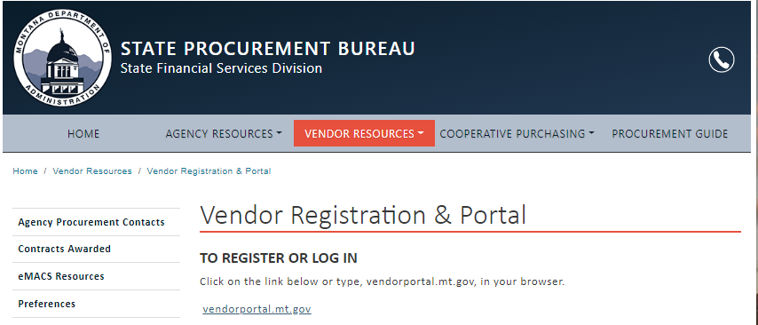
- Click on the vendor portal link.
- Enter the email address used to create vendor registration. Click Next.
- Enter your password. Click LOGIN.
- If you do not remember your password:
- If you remember the answer to your security question, click on TROUBLE LOGGING IN? to reset your password;
- If you don't remember the security question answer, call JAGGAER at 1-800-233-1121 (Option 2 / Option 1). Identify yourself as a registered State of Montana supplier needing a password reset.
In your vendor registration, you'll need to complete the Payment Information and Tax Information sections and submit your registration.
2. Payment Information. In the Payment Information section, you will be asked to provide the necessary information to receive payment for your services from DNRC.
- Click Payment Information in the gray column to the left.
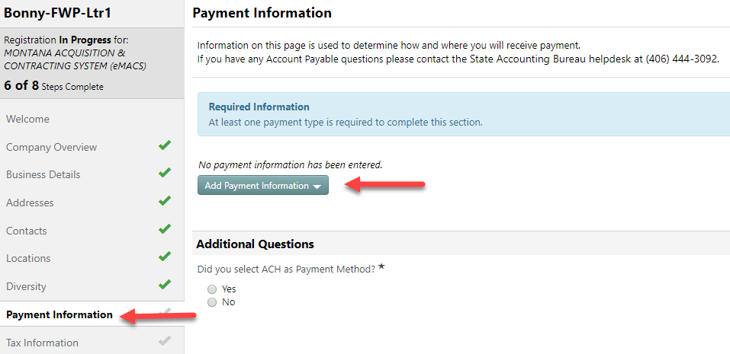
- Click Add Payment Information.
- Select method of receiving payment via Direct Deposit (ACH) or Check (mailed).
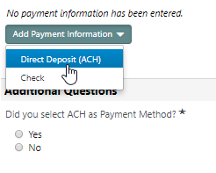
- Enter banking information for ACH or mailing information for check.
- Click Save Changes.
- If you’ve selected ACH, select Yes. Upload either a voided check or direct deposit form from your bank.
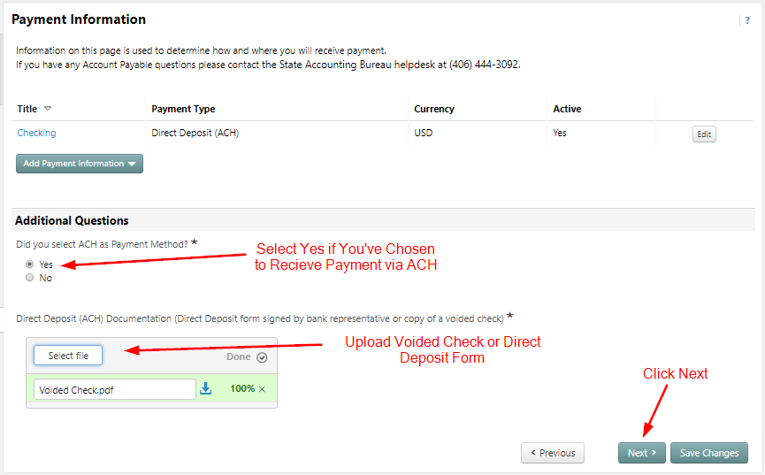
- Click Next.

3. Tax Information. In the Tax Information section, you’ll be asked to provide a W9 form. You can generate a pre-populated W9 document and electronically sign it within the registration wizard.
- Click Tax Information in the gray column to the left.
- Click on Add Tax Document.
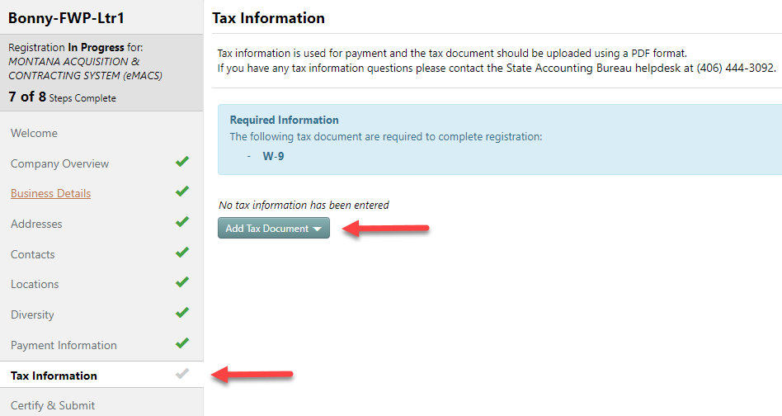
- Select W9.

- Enter a Tax Document Name. This name can be any name you want.
- Click on Download Pre-Populated Tax Document.
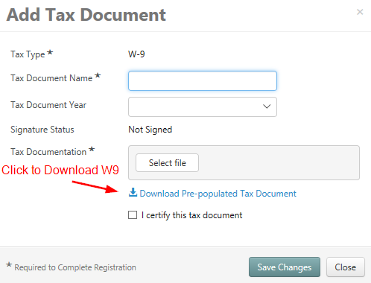

- Open the downloaded W9 document. Information entered should be pre-populated.
- Save W9 document to your computer.
- In the Tax Documentation area, upload the saved W9 by clicking Select file.
  - Select W9 document.
  - Click Open.
- Certify the W9 by checking the I certify this tax document box.
- Type your Vendor Portal password to electronically sign the W9.
- Click Save Changes.
- Click Proceed to Certify and Submit.
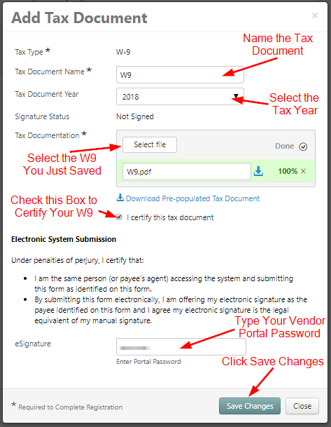

4. Certify & Submit. In this section, you will finalize your Vendor Registration.
- Ensure all previous sections have green checks.
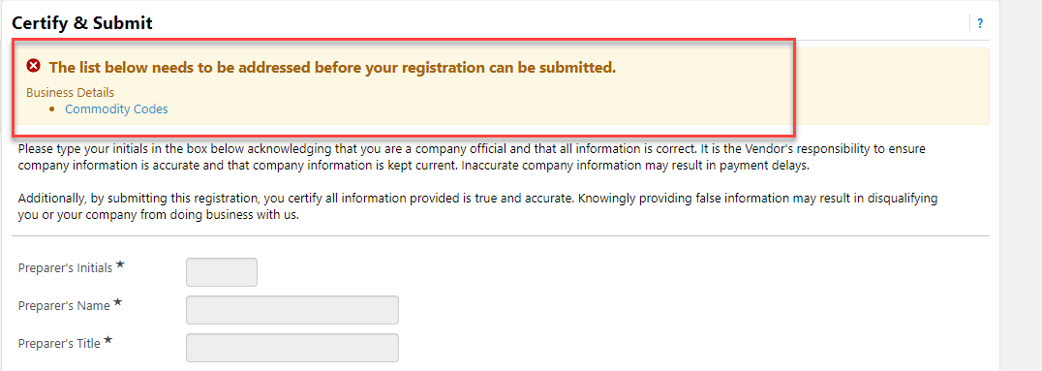
- If any areas are not completed, click on link to go back to area and complete.
- Enter Preparer's Initials, Name, Title, and Email Address.
- Check Certification box to certify your registration.
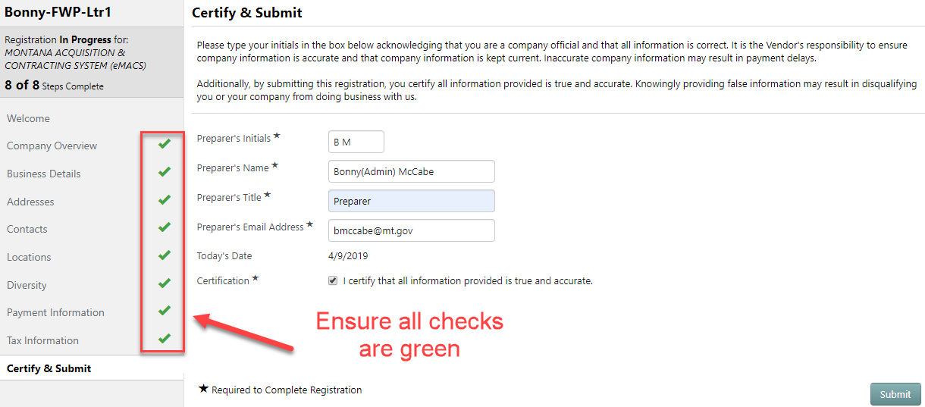
- Click Submit.

