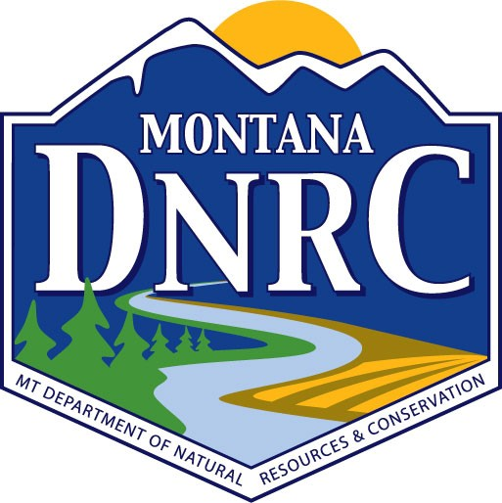
Montana DNRC Dam Safety Complaint Form

Important Note: Per Administrative Rule of Montana ARM 36.14.802, you or your property must be endangered by the dam in order to file a complaint.

Person Filing Complaint:

Name: Address:

Telephone:

E-Mail:

Dam Owner Information:

Name: Address:

Telephone:

Location of Dam or Reservoir:

Description of the problem and supporting information or data (provide photos if possible):

Description of Dam (height of dam, estimate of reservoir size in acre feet, is the dam currently full, is there water exiting an outlet pipe or spillway, etc.)

Have you contacted the dam owner and explained your concerns?

I declare under penalty of perjury that the foregoing is true and correct.

Signature/Date

Mail or email completed form to a DNRC Regional Office

