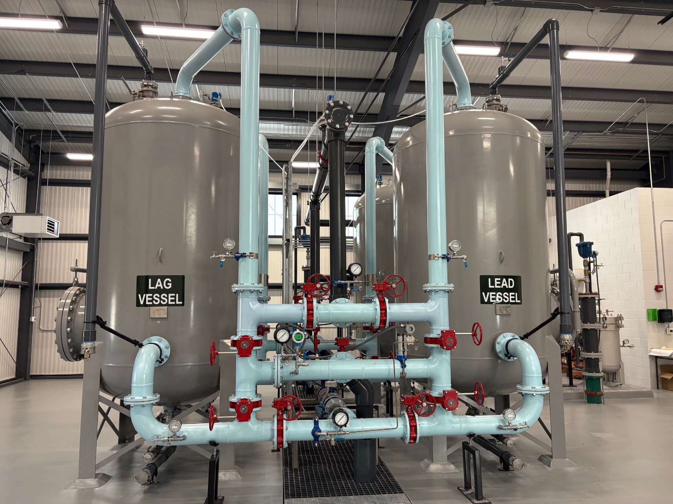
https://dnrc.mt.gov/Conservation/Conservation-Programs/WASACT/

W²ASACT
Water, Wastewater and Solid Waste Action Coordinating Team
December 2025 | 14th Edition

UNIFORM APPLICAION

For Montana Public Facility Projects

UNIFORM APPLICATION FOR MONTANA PUBLIC FACILITY PROJECTS 2
SECTION A – CERTIFICATION 2
SECTION B - SUMMARY INFORMATION 2
SECTION C - FINANCIAL INFORMATION 5
SECTION D - CENSUS DATA 12
SECTION E - SYSTEM INFORMATION 13
SUBSECTION 1 – EQUIVALENT DWELLING UNIT COMPUTATION 15
SUBSECTION 2 – PROJECTED AVERAGE MONTHLY RESIDENTIAL RATE COMPUTATION 17

  - Please see the Uniform Application For Montana Public Facility Projects - Introduction, Instructions and Examples online: https://dnrc.mt.gov/Conservation/Conservation-Programs/WASACT/

UNIFORM APPLICATION FOR MONTANA PUBLIC FACILITY PROJECTS

SECTION A – CERTIFICATION
To the best of my knowledge and belief, the information provided in this application and in the attached documents is true and correct.
Name (printed): _____________________________________________________________________________

Title (printed): ______________________________________________________________________________
(Chief Elected Official or Authorized Representative)
Signature: _________________________________________________________________________________

Date: ______________________________________________________________________________________

SECTION B - SUMMARY INFORMATION
1. NAME OF APPLICANT(S):
PROJECT TITLE:
2. TYPE OF ENTITY
3. FEDERAL TAX ID:
4. UEI (SAM.GOV ID):
5. TYPE OF PROJECT:
6. SENATE DISTRICT:
HOUSE DISTRICT:
6.a. SENATOR NAME:
REPRESENTATIVE NAME:
7. POPULATION SERVED BY PROJECT:
8. NUMBER OF HOUSEHOLDS SERVED BY PROJECT:

9.CHIEF ELECTED OFFICIAL OR AUTHORIZEDREPRESENTATIVE: |  |  | 10.PRIMARY ENTITY CONTACT PERSON:
Name
Title
Street/PO Box
City/State/Zip
Telephone
Email Address
11. PROJECT ENGINEER/ARCHITECT: |  |  | 12. GRANT/LOAN ADMINISTRATOR:
Name
Title
Street/PO Box
City/State/Zip
Telephone
Email Address
13. LEGAL COUNSEL: |  |  | 14. BOND COUNSEL:
Name
Title
Street/PO Box
City/State/Zip
Telephone
Email Address
15. CLERK/CHIEF FINANCIAL OFFICER: |  |  | 16. ACCOUNTANT:
Name
Title
Street/PO Box
City/State/Zip
Telephone
Email Address

17. BRIEF PROJECT SUMMARY: (Refer to instructions and examples)
Historical Information:
Problem:
Proposed Solution:

SECTION C - FINANCIAL INFORMATION
1. ESTIMATED TOTAL PROJECT COST:
2. PROPOSED FUNDING SOURCES
FUNDING SOURCE | TYPE OF FUNDS | AMOUNT | STATUS OF COMMITMENT | LOAN RATES AND TERMS
TOTAL

3. FUNDING STRATEGY NARRATIVE
Refer to the instructions. Answer each question individually.
- What are the conditions for the use of each source of funds?
- When will each source of funds listed be available (month and year)?
- Is there any additional information on the level of commitment for each source of funds listed?
- How will funding sources be coordinated with each other?
- Will interim-loan funds be required as part of the project? If yes, how will they be used and coordinated with other funding sources?
- What other sources of funds from public and private sources have been considered for this project? Explain why they are not being pursued or used for this project.
- If a particular source of funding is not obtained, how will the applicant proceed? Explain how the funding strategy will change if a source of funding is not received.
- What is the level of local financial participation in the project and is that level the maximum that the applicant can reasonably provide?

3. FUNDING STRATEGY NARRATIVE
PROPOSED FUNDING SOURCES | FUNDING STRATEGY NARRATIVE

4. PROJECT BUDGET FORM
GRANT / LOAN ADMINISTRATION | FUNDING SOURCE 1 | FUNDING SOURCE 2 | FUNDING SOURCE 3 | FUNDING SOURCE 4 | FUNDING SOURCE 5 | TOTAL
Personnel Cost
Materials or Supplies
Grant & Loan Administration Professional Services
Legal Costs
Audit Fees
Travel & Training
Loan Fees
Loan Reserves
Interim Interest
Bond Counsel & Related Costs
TOTAL ADMINISTRATION
CONSTRUCTION / PROJECT
Land Acquisition
Engineering - Basic Services
Engineering - Resident Project Representative Services
Engineering - Additional Services
Materials, Supplies, Equipment
Construction
Contingency
TOTAL CONSTRUCTION / PROJECT
TOTAL PROJECT BUDGET

4A. PROJECT BUDGET NARRATIVE
GRANT / LOAN ADMINISTRATION | Narrative Description of Administrative/Financial Costs | Estimated Total Cost
Personnel Cost
Materials or Supplies
Professional Services
Legal Costs
Audit Fees
Travel & Training
Loan Origination
Debt Service Reserves
Interim Interest
Bond Costs
TOTAL ADMINISTRATION
CONSTRUCTION / PROJECT | Narrative Description of Administrative/Financial Costs | Estimated Total Cost
Land Acquisition
Engineering - Basic Services:
Preliminary Engineering Report
Preliminary Design
Final Design
Bidding
Construction Administration
Post Construction
Engineering - Resident Project Representative Services
Engineering - Additional Costs:
Geotechnical Report
Hydrologic Assessment
Permitting
Easements and Rights-of-Way
Licenses
Grant and Loan Project Support
Licensing
Special Surveys
Equipment
Construction
Contingency
TOTAL CONSTRUCTION / PROJECT | Sum of the Construction/Project Related Costs
TOTAL PROJECT BUDGET | Sum of the Administration and Construction/Project Costs
Completed by:
Date:

5. CURRENT DEBT
Year Issued | Purpose | Type of Bond/Security | Amount | Maturity Date (m/yr) | Debt Holder | Coverage Requirement | Avg. Annual Payment Amount | Outstanding Balance

6. CURRENT ASSETS
Asset | Details | $
Cash
Investments
Certificate of Deposit
Accounts Receivables
Other Current Assets
 | Indicate if assets are obligated.

7. BALANCE SHEET
____ If applying to SRF or RD, attach a Balance Sheet. Contact the other funding programs to determine if a balance sheet is required.
8. INCOME AND EXPENSE STATEMENT
____ If applying to SRF or RD, attach an Income and Expense Statement. Contact the other funding programs to determine if this is required.

SECTION D - CENSUS DATA
Do not fill in this section. The following information will be completed by the receiving agency using data supplied U.S. Bureau of the Census and the U.S. Department of Housing and Urban Development based on Census data.
1. MEDIAN HOUSEHOLD INCOME ($)
2. LOW TO MODERATE INCOME PERSONS: The percent of the population at 0.00% or below the level designated as low to moderate income. (%)
3. POVERTY: The percentage of the population characterized as at or below the 0.00% level designated as poverty. (%)

SECTION E - SYSTEM INFORMATION
Number of unimproved properties in jurisdiction:
 | Current |  | Projected
1. Total System Annual Revenue ($)
2. Total System Annual Operation and Maintenance Costs ($)
Projected costs must match the Projected System Operation and Maintenance Cost Table.
3. Total System Equivalent Dwelling Units* (#) |  | (e) |  | (k)
4. Total Residential Equivalent Dwelling Units* (#) |  | (f) |  | (m)
5. Annual Revenue from Residential Hookups ($)
Show calculation on how to determine the annual revenue from residential hookups:
6. Percent of Total Annual Revenue from Residential Hookups (%)
7. Average Monthly Water Residential Rate ($) |  | (w) |  | (x)
Is this a flat rate? (yes or no) |  |  |  | (y)
8. Average Monthly Wastewater Residential Rate ($) |  | (w) |  | (x)
Indicate if this is/will be a flat rate. |  |  |  | (y)
9. Average Monthly Combined Water & Wastewater Rate ($) |  | (w) |  | (x)
Indicate if this is/will be a flat rate. |  |  |  | (y)
10. Other System (e.g. Solid Waste, Stormwater, Irrigation) Average Monthly Residential Rate ($) |  | (w) |  | (x)
Indicate if this is/will be a flat rate. |  |  |  | (y)
*If the application is for a solid waste, stormwater or irrigation project, enter both the current and projected total number of customers.

PROJECTED SYSTEM OPERATION AND MAINTENANCE COST
Personnel (i.e. Salary, Benefits, Payroll Tax, Insurance, Training) ($)
Administrative Costs (e.g. office supplies, printing, etc.) ($)
Water Purchase or Waste Treatment Costs ($)
Insurance ($)
Energy Cost (Fuel and/or Electrical) ($)
Process Chemical ($)
Monitoring & Testing ($)
Short Lived Asset Maintenance/Replacement ($)
Professional Services ($)
Residuals Disposal ($)
Miscellaneous ($)
Total ($) | $

SUBSECTION 1 – EQUIVALENT DWELLING UNIT COMPUTATION
Applicants with either a water and wastewater project must complete Section 1, regardless of whether the applicant is served by a central water system or is planning to charge residential users a flat user fee. If the applicant is not served by a central water system, or it has water connections that provide service to multiple mixed uses, such as commercial and residential, refer to the instructions section for information on computing the number of EDUs.
Applicants with solid waste, stormwater or irrigation projects are not required to complete Subsection 1.
Service connection diameters will be converted to EDUs according to the following table, except for those situations noted in the instructions:
Service connection inside diameter (inches) | EDUs
¾” or smaller | 1.00
1" | 1.79
1-1/2" | 4.00
2" | 7.14
2-1/2" | 11.16
3" | 16.00
4" | 28.57
5" | 44.64
6" | 64.29
7” | 87.11
8” | 113.78
9” | 144.00
10” | 177.78

PART A. CURRENT WATER HOOKUP SUMMARY
Current Total Hookups  (residential and non-residential) |  |  |  | Current Residential Hookups
Diameter  (inches) | (a)  Total Number of Hookups | (b)  EDUs per Hookup  (from table) | Total EDUs  [(a) x (b)] | Diameter  (inches) | (c)  Total Number of Hookups | (d)  EDUs per Hookup  (from table) | Total Residential EDUs  [(c) x (d)]
 |  |  | 0 |  |  |  | 0
 |  |  | 0 |  |  |  | 0
 |  |  | 0 |  |  |  | 0
 |  |  | 0 |  |  |  | 0
 |  |  | 0 |  |  |  | 0
 |  |  | 0 |  |  |  | 0
 |  |  | 0 |  |  |  | 0
 |  |  | 0 |  |  |  | 0
 |  |  | 0 |  |  |  | 0
 |  |  | 0 |  |  |  | 0
 |  |  | 0 |  |  |  | 0
Totals |  |  |  | Totals
 |  |  | (e) |  |  |  | (f)

PART B. PROJECTED WATER HOOKUP SUMMARY
Projected Total Hookups  (residential and non-residential) |  |  |  | Projected Residential Hookups
Diameter  (inches) | (g)  Total Number of Hookups | (h)  EDUs per Hookup  (from table) | Total EDUs  [(a) x (b)] | Diameter  (inches) | (i)  Total Number of Hookups | (j)  EDUs per Hookup  (from table) | Total Residential EDUs  [(c) x (d)]
 |  |  | 0 |  |  |  | 0
 |  |  | 0 |  |  |  | 0
 |  |  | 0 |  |  |  | 0
 |  |  | 0 |  |  |  | 0
 |  |  | 0 |  |  |  | 0
 |  |  | 0 |  |  |  | 0
 |  |  | 0 |  |  |  | 0
 |  |  | 0 |  |  |  | 0
 |  |  | 0 |  |  |  | 0
 |  |  | 0 |  |  |  | 0
 |  |  | 0 |  |  |  | 0
Totals |  |  |  | Totals
 |  |  | (k) |  | (l) |  | (m)
Projected average EDUs per residential hookup (n):
[(m)/(l)]

Provide the following information if applying to the USDA RUS/RD program
Total water system flows (sales) last twelve months for all connections listed in (a) above:
 | gallons | OR |  | cubic feet
Total residential water flows (sales) last twelve months for all connections listed in (c) above:
 | gallons | OR |  | cubic feet

NOTE: Provide a detailed monthly split of the residential and non-residential sales, if applicable. A sample spreadsheet is available on the Montana USDA Rural Development website at http://www.rd.usda.gov/programs-services/water-waste-disposal-loan-grant-program/mt.

SUBSECTION 2 – PROJECTED AVERAGE MONTHLY RESIDENTIAL RATE COMPUTATION
1. Will debt be used to finance the project?  (Yes or No) |  | If no, skip to PART E
A. Revenue Bond (Yes or No). |  | If yes, complete PART A
B. General Obligation Bond (Yes or No). |  | If yes, complete PART B
C. Rural or other Special Improvement District (Yes or No). |  | If yes, complete PART C
D. Other (explain): |  | If yes, complete PART C
2. Debt (Loan) Amount ($):
3. Interest Rate (%):
4. Terms:

PART A. REVENUE BOND SECURING DEBT OBLIGATION:
1. Debt election held? (Yes or No)
If no, when will the election be held? (Date)
2. Annual debt service for new loan, including coverage ($): |  |  | (i)
3. Monthly debt service for new loan, including coverage (i)/12: |  |  | (ii)
4. Total number of projected EDUs after completion of the project: |  |  | (iii)
5. Average (per total projected EDUs) monthly debt service for new loan:  (line ii / line iii) |  |  | (iv)
PART B. GENERAL OBLIGATION BOND SECURING DEBT OBLIGATION:
1. Debt election held? (Yes or No)
If no, when will the election be held? (Date)
2. Amount of outstanding General Obligation Bonds ($):
3. Debt limitations of entity:
4. Estimated average monthly assessment (per property) needed to repay debt ($):
(annual assessment/12)

PART C. RURAL OR SPECIAL IMPROVEMENT DISTRICT BOND SECURING DEBT OBLIGATION:
1. Type of special assessment:
a. SID
b. RID
c. Other (specify)
2. Proposed method of assessment:
a. Assessable Area:
b. Area:
c. Ad Valorem Tax:
d. Lineal Front Footage:
e. Combination of a. through d. above: (explain)
3. Number of parcels in the district:
4. What percentage of the property within the district fits these descriptions? Complete table below.
(based on the methods of assessment)
TYPE OF PROPERTY | PERCENT DEVELOPED | PERCENT UNDEVELOPED
Commercial
Industrial
Single-Family Residential
Multi-Family Residential
Agricultural
5. Number of property owners in district:
6. Estimated average monthly assessment needed to repay debt (per property) ($):
(annual assessment /12)

PART D. OTHER TYPE OF DEBT INSTRUMENT SECURING DEBT OBLIGATION THAT IS NOT INDICATED ABOVE
1. Explain how debt will be secured:
2. Estimated average monthly cost to repay debt per property ($):

PART E. CALCULATION OF THE PROJECTED AVERAGE MONTHLY RESIDENTIAL USER RATE:
1. Estimated Increase in Monthly Debt Service per EDU or Customer ($): |  | (o)
 | [From Part A, B, C or D]
2. Change in Monthly O&M Costs for System ($): |  | (p)
3. Explanation of Change of Monthly O&M Costs:
4. Change in Monthly O&M Costs per EDU or Customer ($): |  | (q)
4. Change in Monthly O&M Costs per EDU or Customer ($): | [(p)/(k)]
5. Change in Total Monthly Costs per EDU or Customer ($): |  | (r)
5. Change in Total Monthly Costs per EDU or Customer ($): | [(o)+(q)]
6. Average EDUs per Residential Hookup (Projected): |  | (s)
6. Average EDUs per Residential Hookup (Projected): | [(n)]
7. Change in Total Monthly Costs per Residential EDU or Customer ($): |  | (t)
 | [(r)x(s)]
8. Existing Average Monthly Residential Debt Service ($): |  | (u)
9. Existing Average Monthly Residential O&M Costs ($): |  | (v)
Note: (u) + (v) should equal the current average monthly residential rate (w) as stated in Section E.
 | [(u) + (v)]
 | [(w)]
If these amounts do not equal, provide an explanation of why the numbers differ:
10. Projected Average Monthly Residential User Rate ($):
10. Projected Average Monthly Residential User Rate ($): | [(t) + (u) + (v)]
Note: [(t) + (u) + (v)] should equal the projected average monthly residential rate (x) as stated in Section E.
 | [(x)]
If these amounts do not equal, provide an explanation of why the numbers differ:
11.Residential Flat Rate (Projected) ($):
Note: The Residential Flat Rate in 11 should equal the Projected Flat Rate (y) in Section E.
 | [(y)]
If these amounts do not equal, provide an explanation of why the numbers differ:

