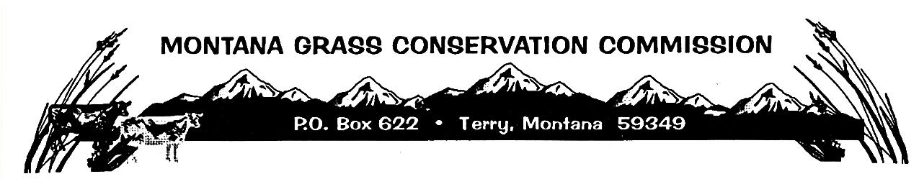

Montana Grass Conservation Commission
Zoom Meeting Agenda
December 23rd, 2024 8:00 a.m. – 9:30 a.m.
Call to Order – Chairman, Richard Stuker
- Minutes from Montana Grass Conservation Commission previous meeting on December 10th, 2024, Zoom. – Action Item Public Comment
- RFP Evaluation and Approval – Action Item Public Comment
- Public Comment or any other business that comes before the Montana Grass Conservation Commission Board

