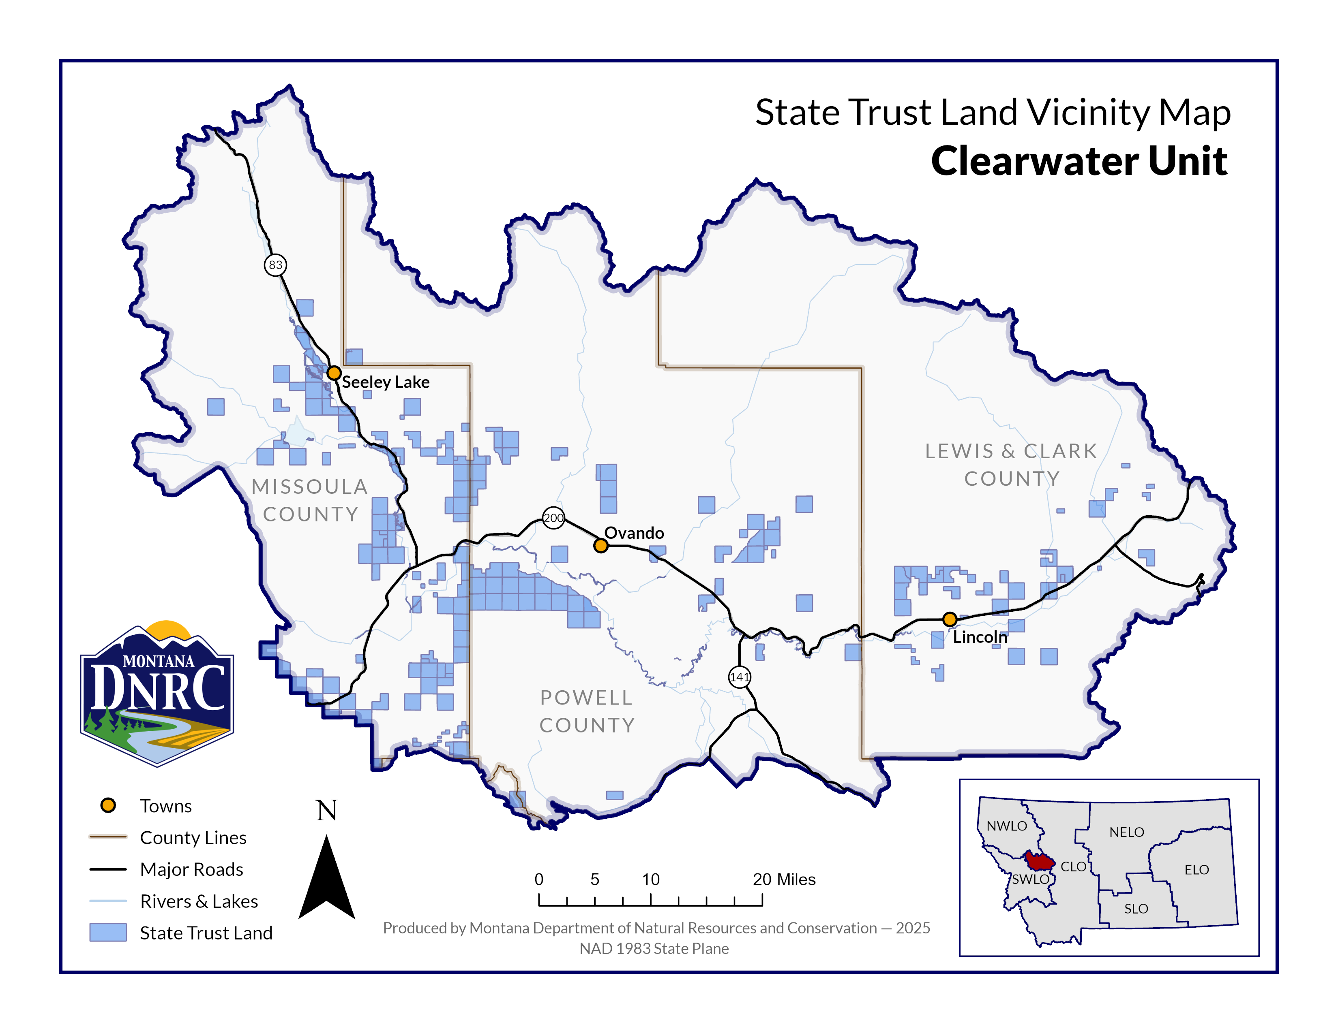
Section: 18
Township: 15 North
Range: 14 West

County: Missoula
Fast Horse Timber Sale
Attachment A-1

