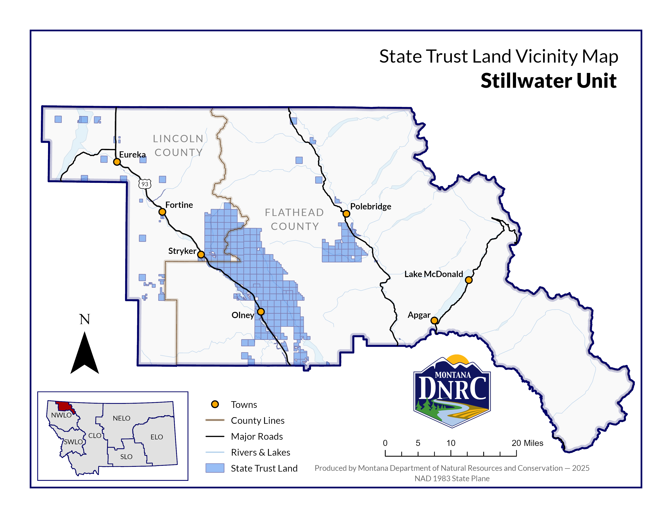
Section: 16
Township: 37N
Range: 28W

County: Lincoln
Young Creek Timber Sale

