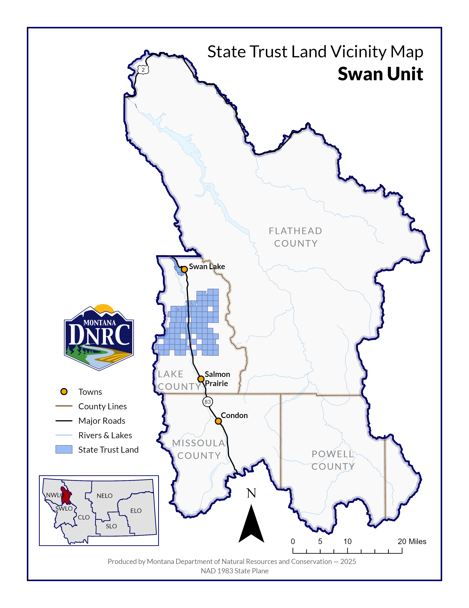
`
Section: 28
Township: 23N
Range: 17W

County: Lake
Twister Loop Timber Sale

