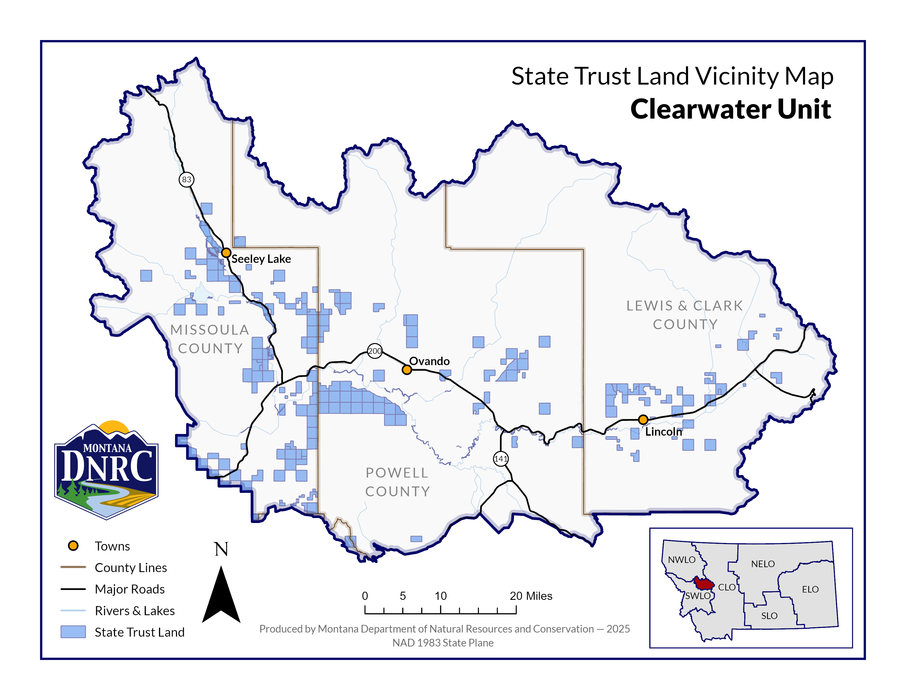
Sunset Potomac Timber Sale

Sections: 14 and 24
Township: 13 N
Range: 15 W

County: Missoula

