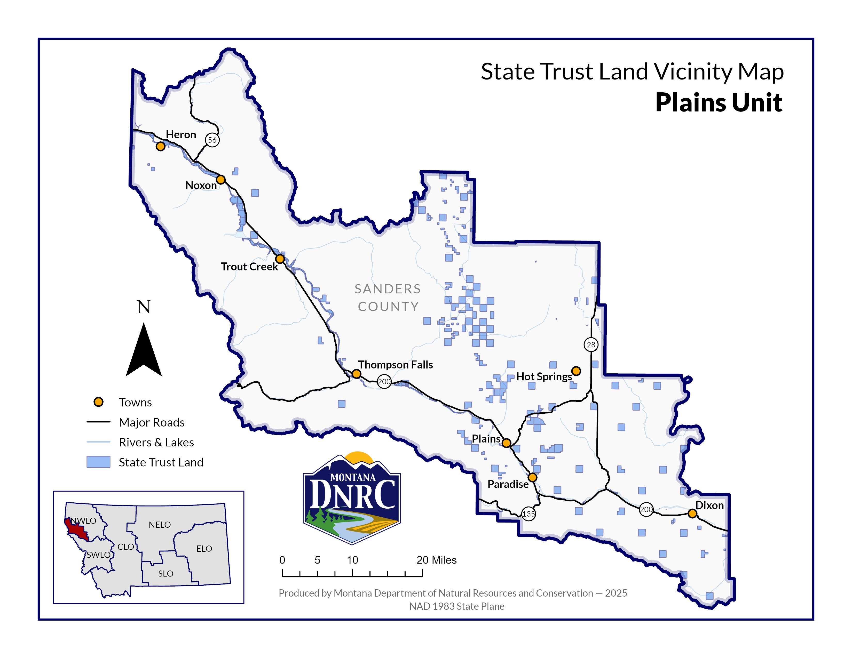

**Section: 24 & 26**

**Township: 23N**

**Range: 27W**

**County: Sanders**

*Stobie Ranch Timber Sale*