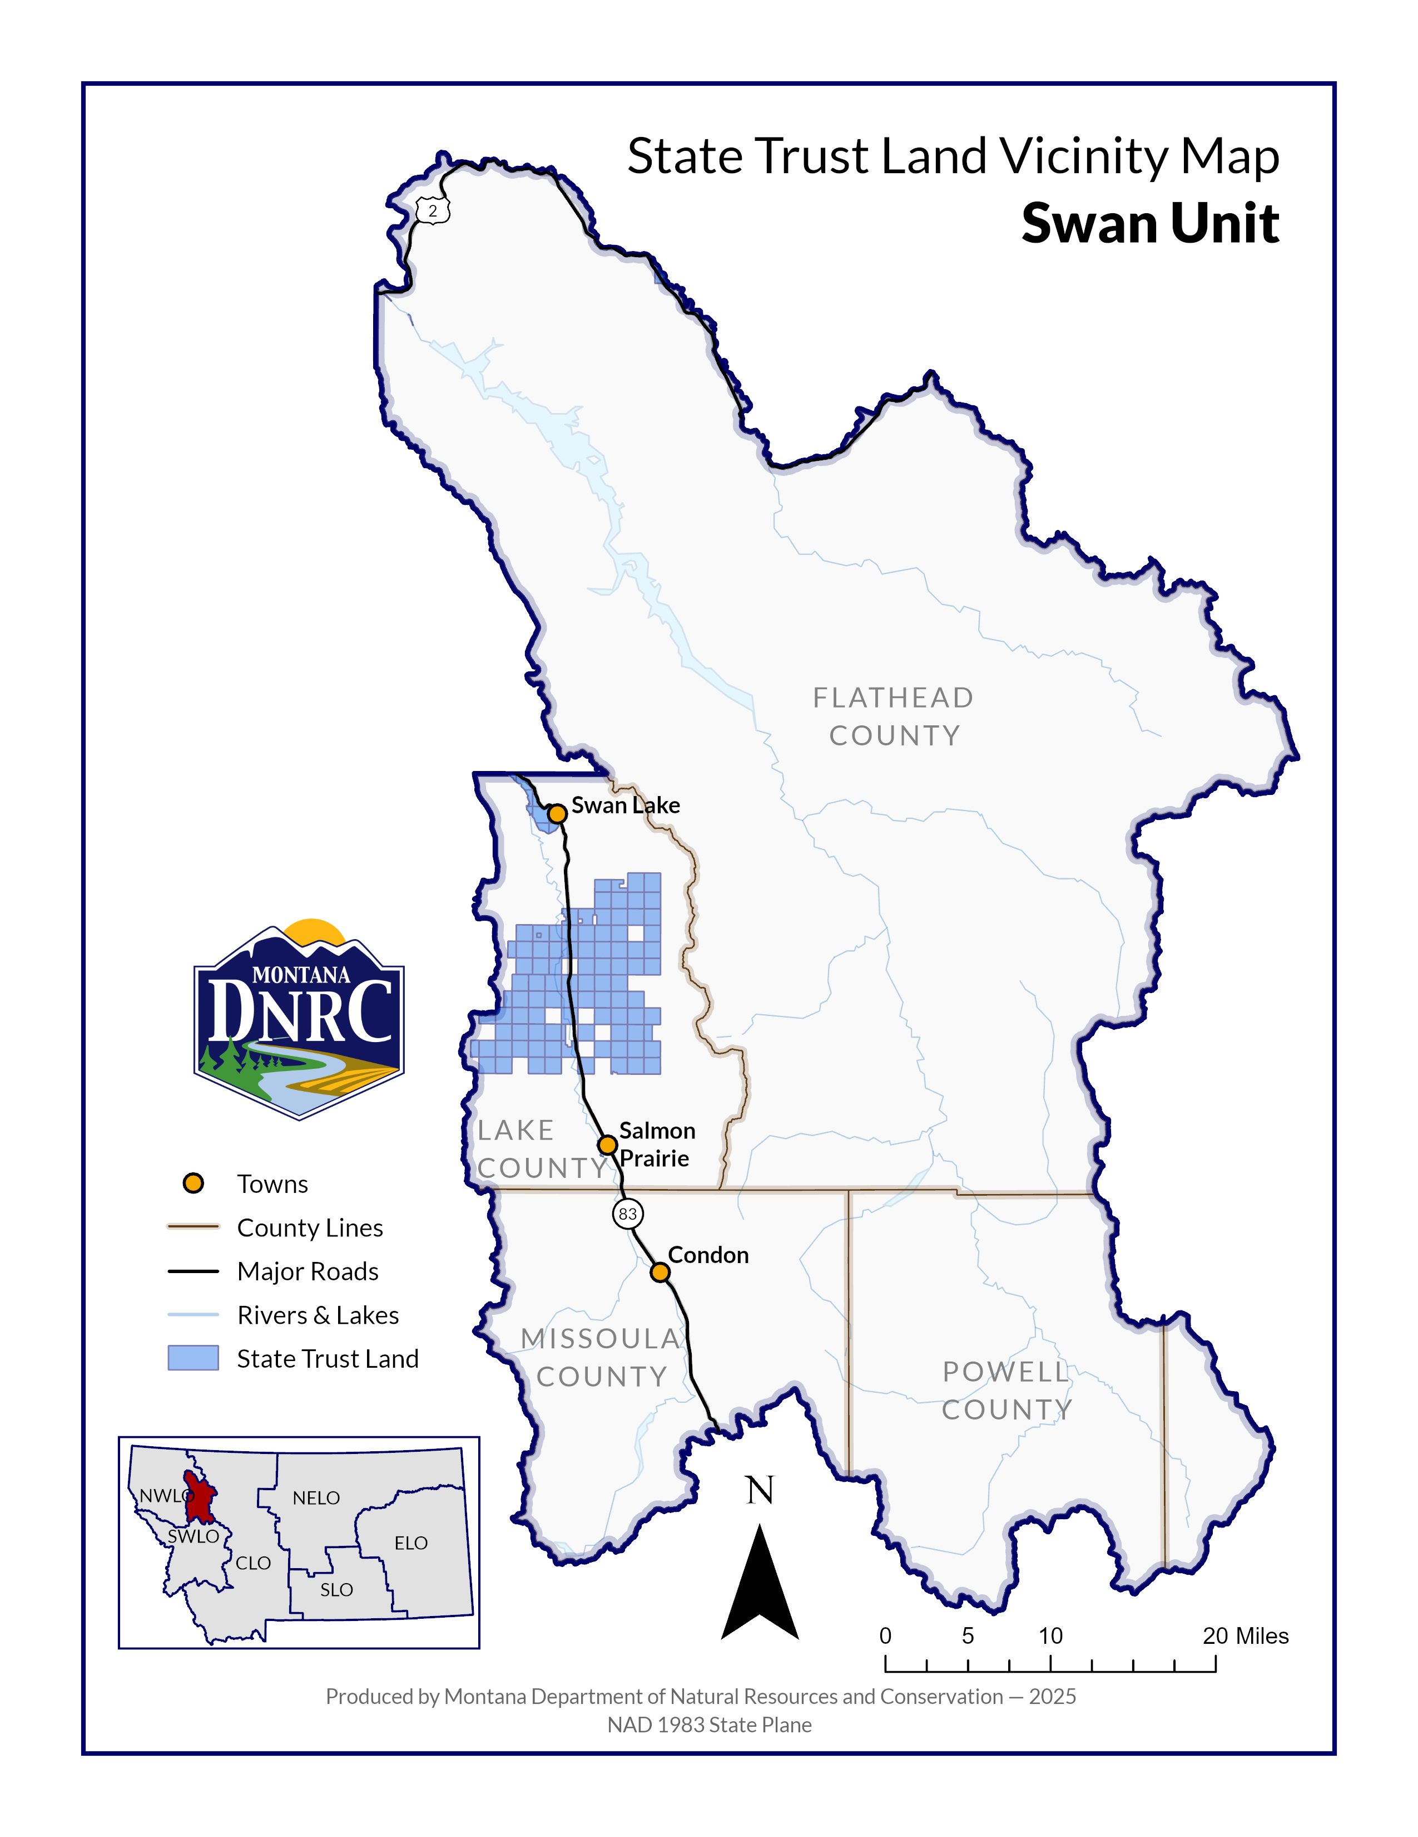 `

**Sections: 4 and 5**

**Township: 23N**

**Range: 17W**

**Sections: 27, 28, 29, 32, 33, & 34**

**Township: 24N**

**Range: 17W**

**County: Lake**

*Napa Creek Timber Sale*