A-1: Vicinity Map
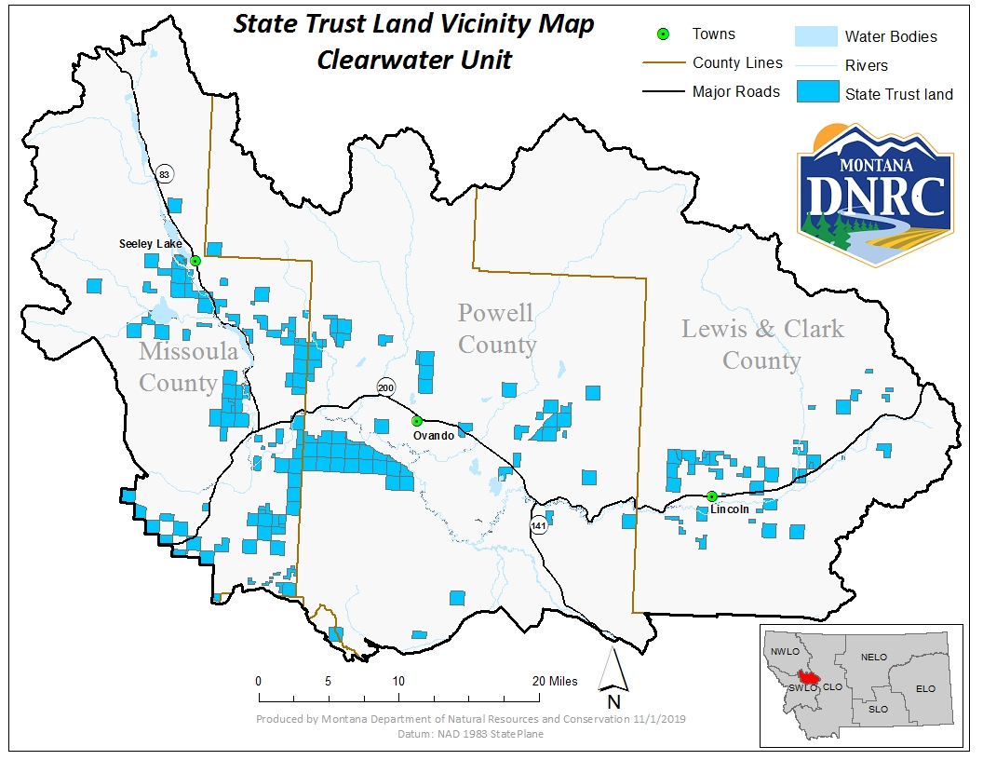

Name: Loose Horse Timber Sale
Legal: T15N R14W Sec 19 & 30
Loose Horse Timber Sale

