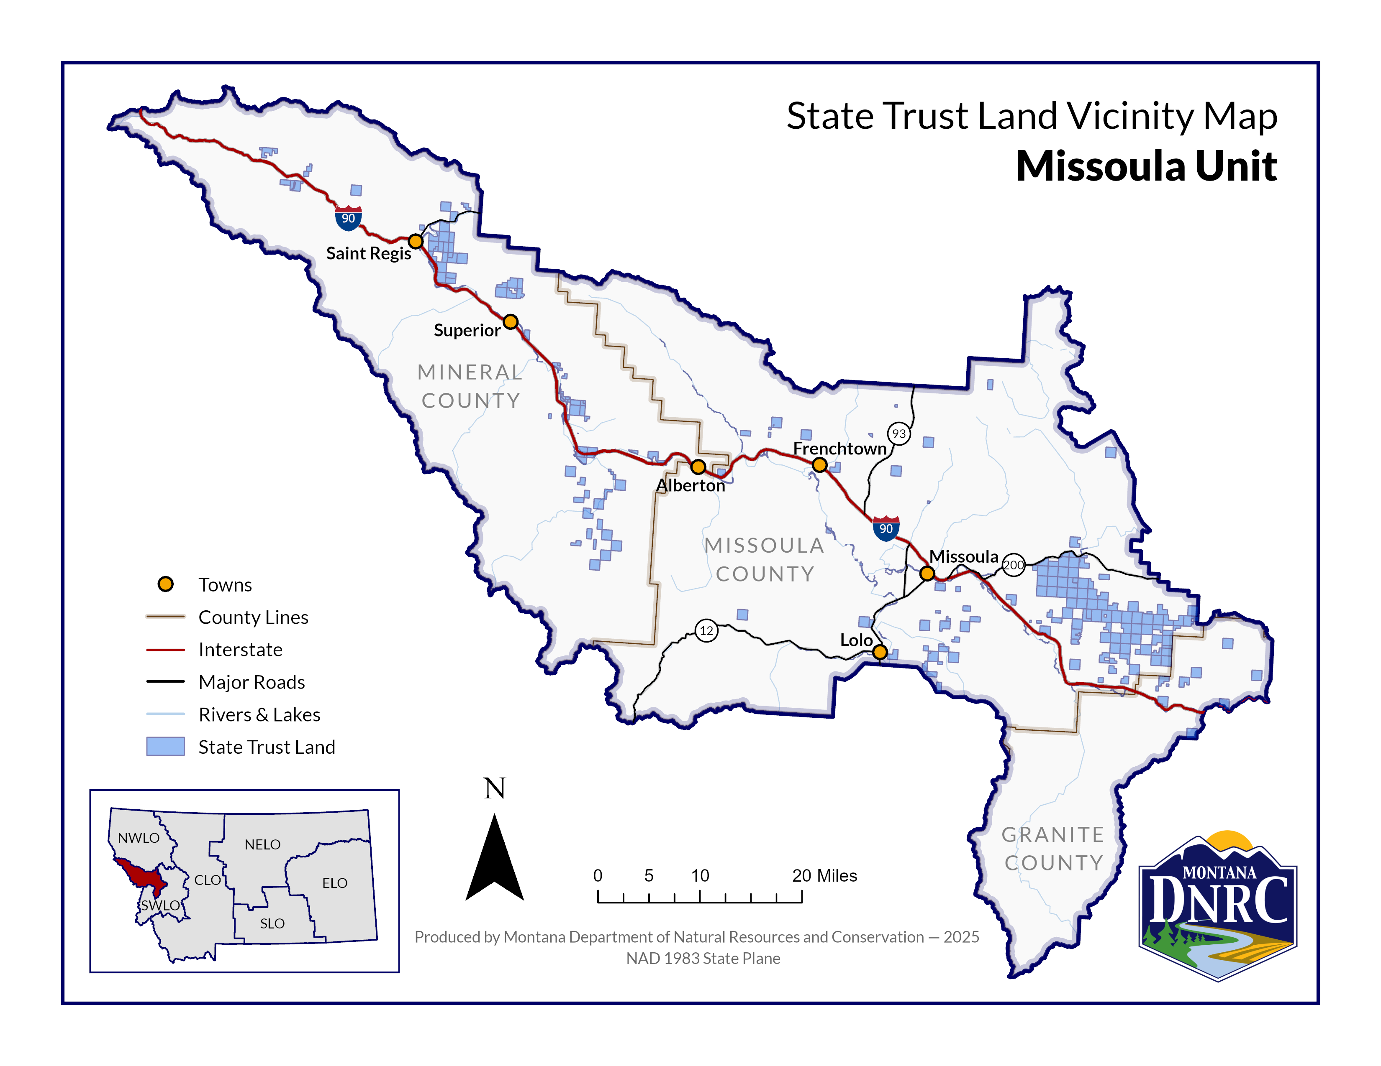
Lion Point
Timber Sale
Sections: 16,30
T14N R24W
Sections: 24,26,36
T14N R25W
County: Mineral
Lion Point Timber Sale

