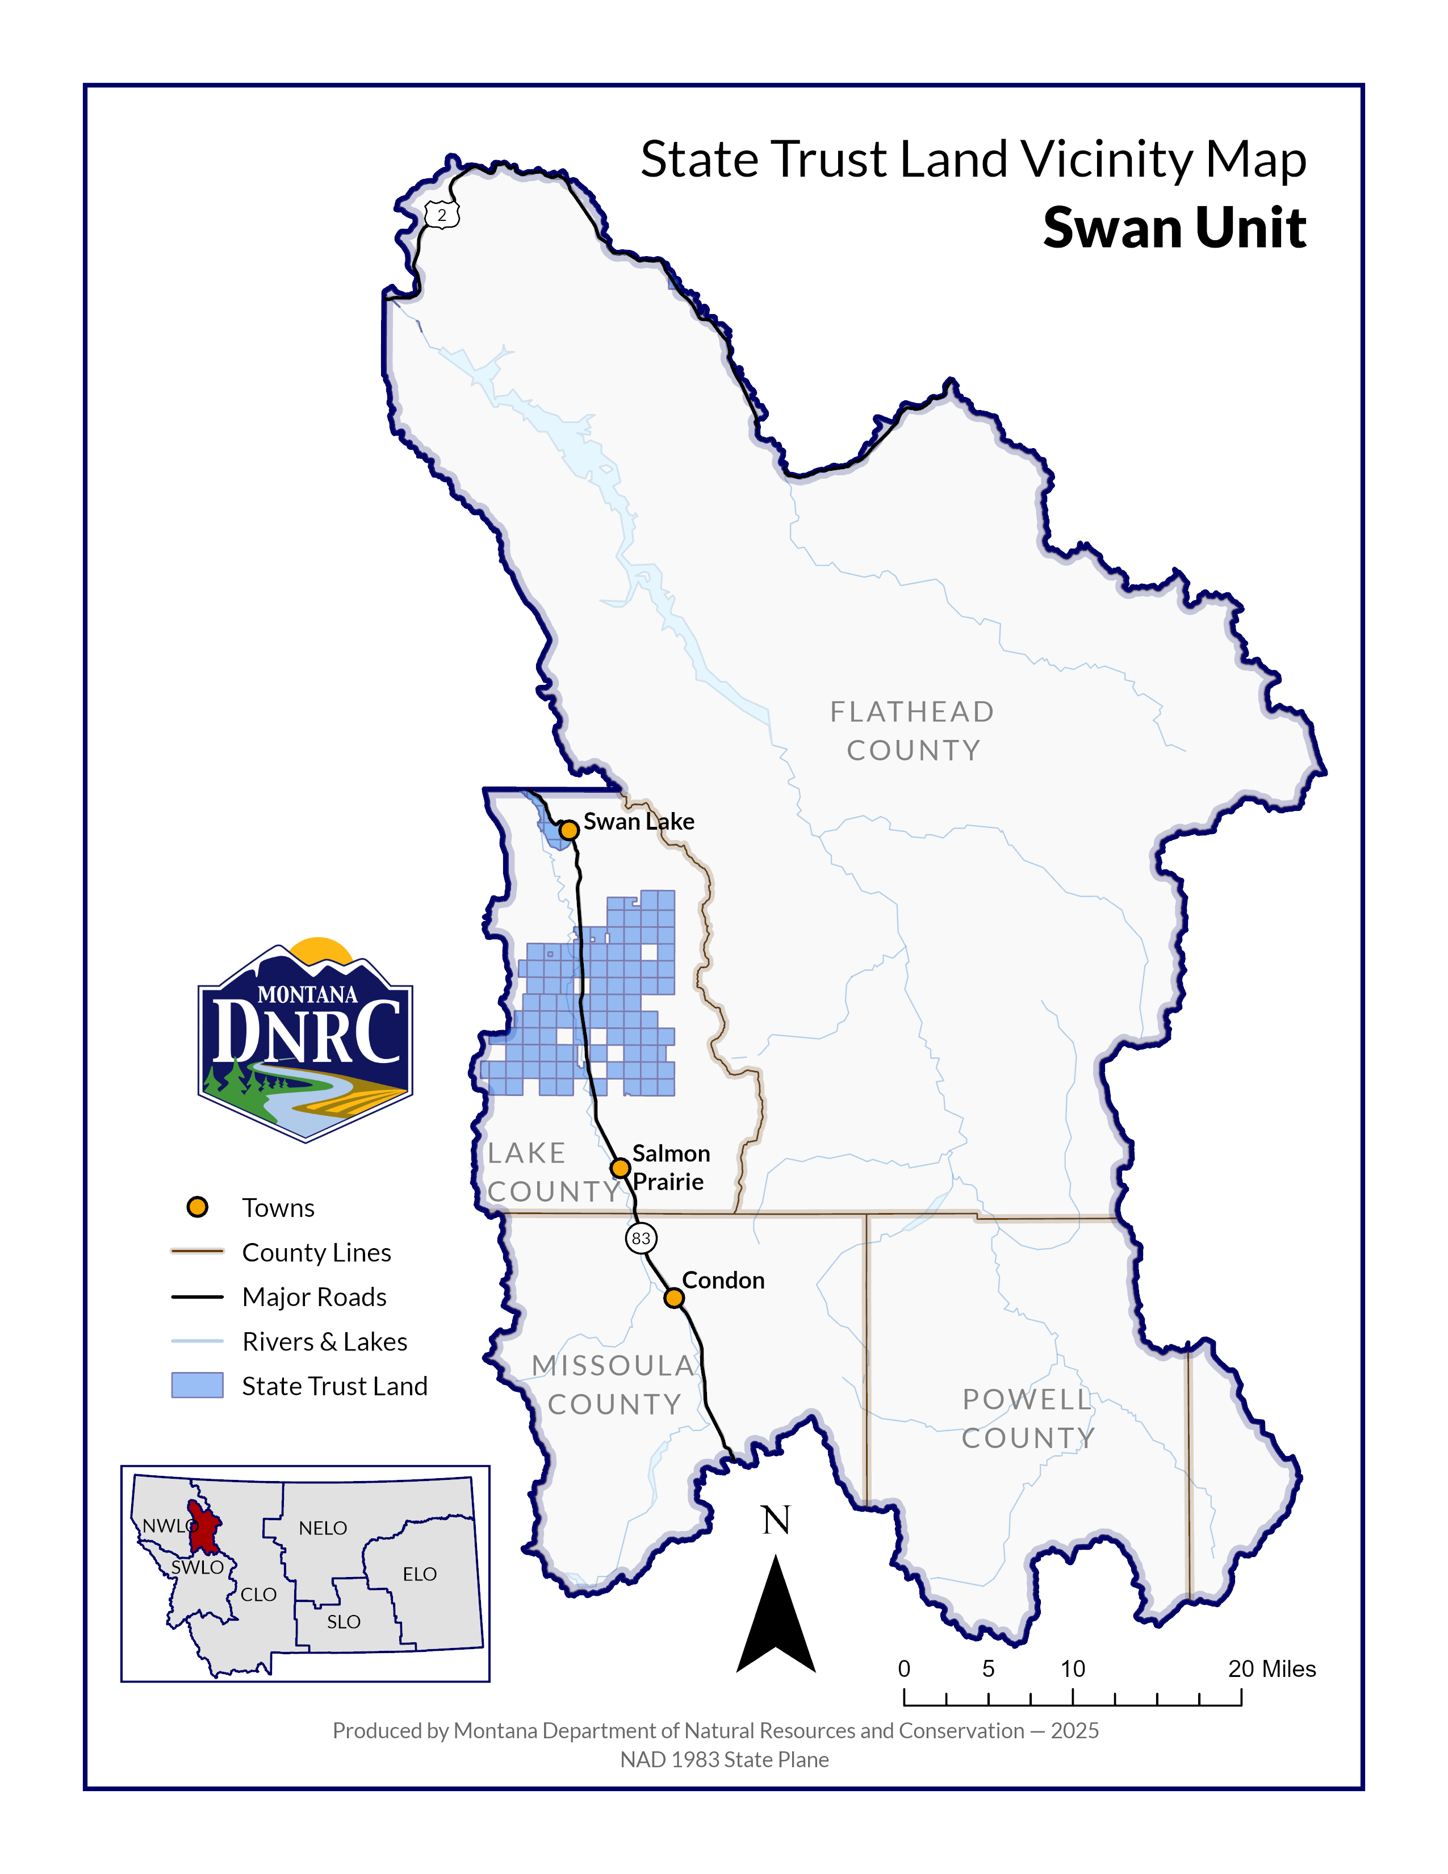
`
Sections: 3, 4, 5, 7, 8, 9, & 10
Township: 23N
Range: 17W

County: Lake
In-pa-ah Timber Sale
(name is of Salish Tribal origin meaning “Burned Over Ground”

