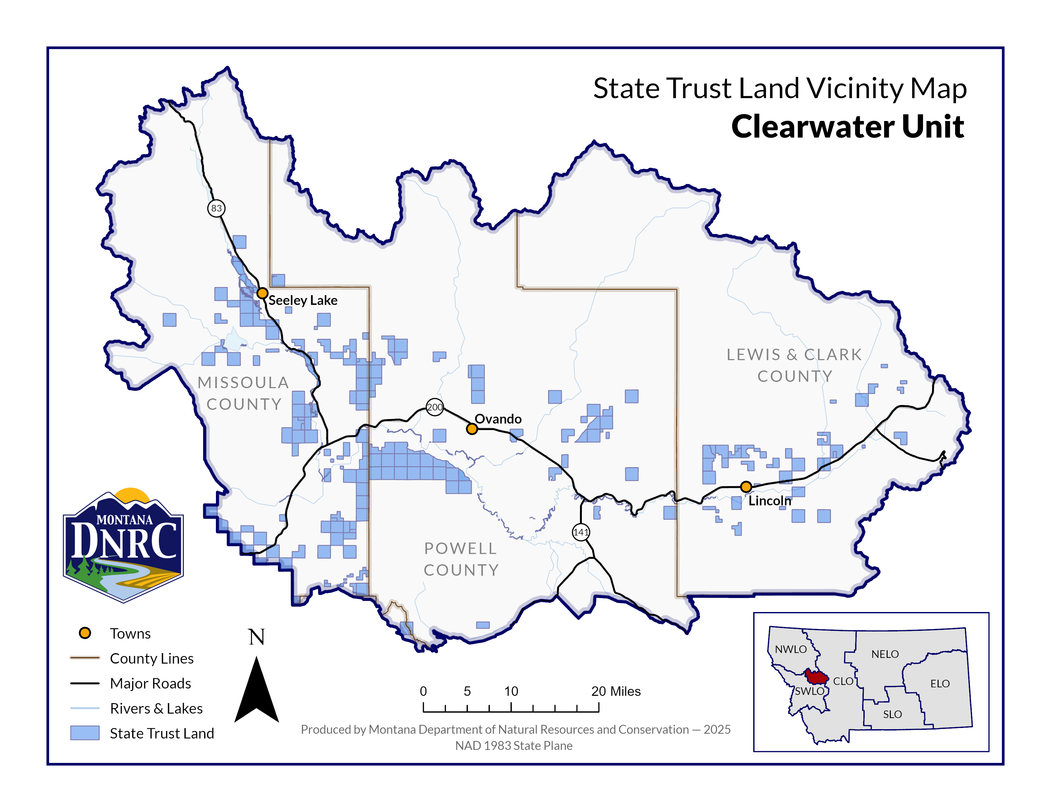
Fish Stix Timber Permit
Section: 32
Township: 16N
Range: 14W
County: Missoula

