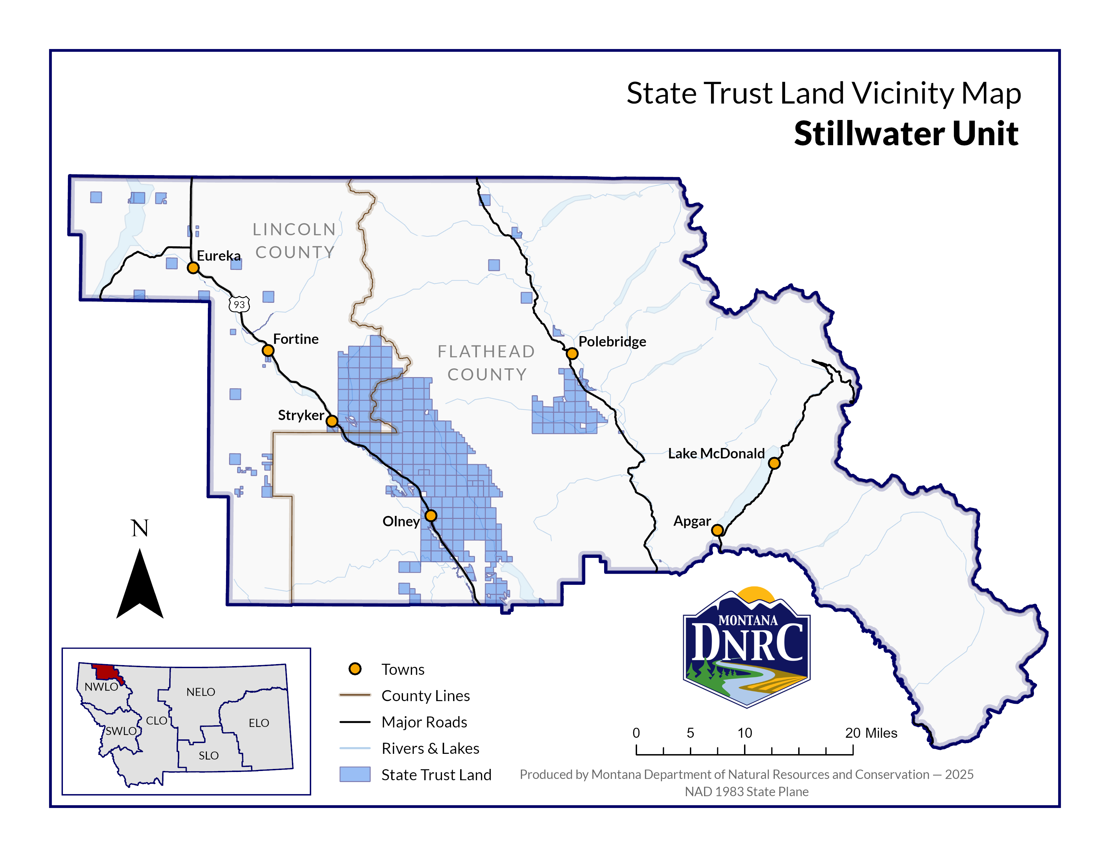
Sections: 2, 11, 12, 13, 14, 23, 24, & 25
Township: 33N
Range: 24W and
Sections: 7, 17, 18, 19, 20, 21, 28, 29, 30, & 32
Township: 33N
Range: 23W

County: Flathead
Dog Rock Timber Sale

