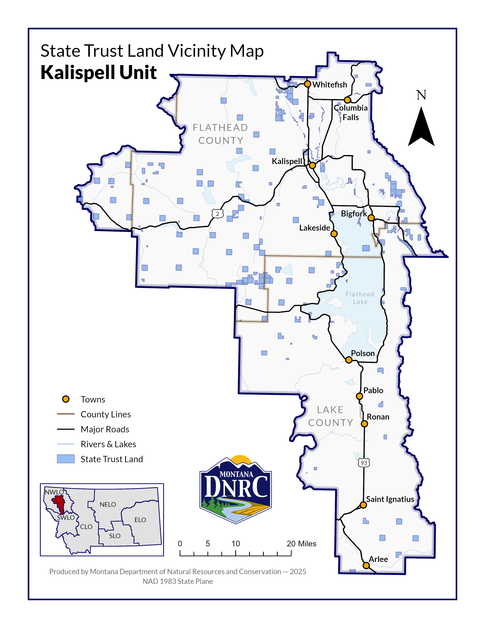

Attachment A

*Davis Mountain Timber Sale*

**Section: 36**

**Township: 27N**

**Range: 28W**

**County: Lincoln**