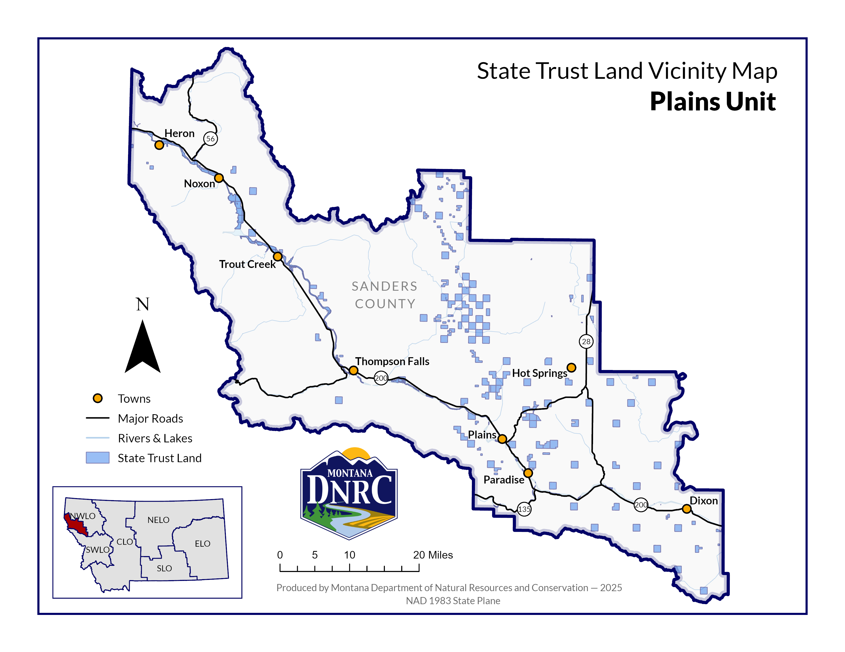
Banana Fire Salvage Timber Sale

Sections: 4 & 5
Township: 20N
Range: 25W

County: Sanders

