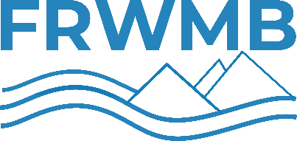
Flathead Reservation Water Management Board
DRAFT Meeting Agenda
Thursday January11th, 2024, from 3-6 PM
Zoom Link: https://zoom.us/j/99687817082
Phone: +1(669) 900-6833 | Webinar ID: 996 8781 7082

- Call to Order (FRWMB Chair)
  - Opening Prayer
  - Attendance
  - Announce meeting minutes on https://www.frwmb.gov (cross-posted on DNRC & CSKT Websites)
  - Disclose any potential conflicts of interest
  - Adopt Agenda
- Public Comment (for items not on the agenda)
- Board Business (FRWMB Chair)
  - Approve meeting agenda-minutes from December 20th, 2023
  - Health Insurance Committee Update
- FRWMB Appeals and Hearings Documents (Legal Counsel)
  - Discussion of Appeals and Hearings Documents
  - Public comment period closed on 1/2/2024 - no comments received by OE
  - Public Comment
  - Board action on Final action on Appellate Rules of Procedure
  - Board action on Final action on Appellate Operating Rules
- Water Engineer’s Report (Water Engineer)
  - Discussion of policy on personal identifiable information
  - Board action on personal identifiable information policy
  - Present Customer feedback survey
- FRWMB Consideration of Complaint Form and Process (609F) (Legal Counsel & Water Engineer)
  - Discussion of Complaint Process
  - Discussion of Complain Forms: 609F (informal) &610F (formal)
  - Public Comment
  - Board action on Complaint Process and/or Forms 609F & 610F
- Application fee and some formatting updates on active Forms in response to HB114
  - Discussion of package of Form updates:
    - 60DF-A & B – Domestic Allowance
    - 60SF-A & B – Stock Allowance
    - 464F-A & B – Geothermal Allowance
    - 634F – Replacement Well
    - 635F – Redundant Well
    - 625F – Reduction Correction
  - Public Comment
  - Board action on package of Form updates
- Board consideration of OE Applicant Update form- 620F
  - Discussion of OE Applicant Update Form 620F
  - Board Action on OE Applicant Update Form 620F
- Continued Water Policy and Procedure working session (If time allows) (Water Engineer)
- Public Comment
- Next Steps/Meetings: ????
- End Meeting (FRWMB Chair)

