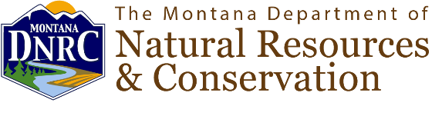

FOR IMMEDIATE RELEASE
June 6, 2025
Contact: KarenDe Herman
Communications Specialist
406-444-5581

DNRC to Hold a Public Hearing on a Proposed Recreation Closure on State Trust Land Near Logan
HELENA, Mont.—The Montana Department of Natural Resources and Conservation (DNRC) is holding a public hearing at 10 a.m. on Wednesday, June 18 in Three Forks regarding a petition received by the agency to close four tracts of state trust land near the unincorporated community of Logan, Mont.
The tracts near Logan currently allow for recreational use and include areas that are heavily used for target shooting. A seasonal firearm restriction is in place from April 15 to June 30 for one of the tracts. The petition received by the DNRC requests full closure to all recreational activity.
The public hearing will include a brief presentation with opportunity for public comment. DNRC is accepting public comment on the closure petition until June 18, 2025.
Actions could include granting the petition for closure, modifying the current recreational use onsite or denying the closure.
For more information on the petition for recreation closure, and to submit public comment or attend the public hearing, visit: https://dnrc.mt.gov/News/dnrc-news/closure-petition
FWP recently applied for an easement for a formal shooting range on one of the tracts. That application is a separate process. More information can be found on their website at: https://fwp.mt.gov/public-notices/news/2025/march/0324-public-scoping-logan-public-shooting-range-project-march-24-2025

###

About DNRC:
The DNRC’s mission is to help ensure that Montana's land and water resources provide benefits for present and future generations.

