[DAM Name]
5-Year Dam Evaluation Preparation
Dam owner Questionnaire
Inventory No. [MT-0000]
[County], Montana

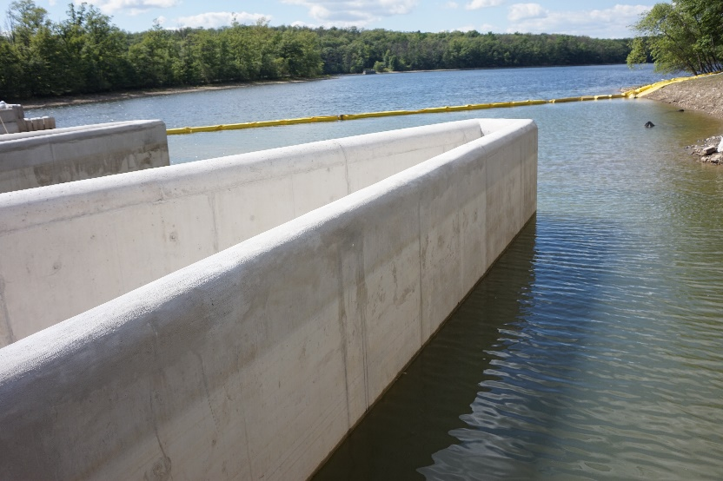

January 1, 2023

Dam Owner
Dam Owner: [Name]
Dam Owner Representative: [Name]

BACKGROUND INFORMATION
- Dam Information
Dam Name: |  | [Dam Name] | Inventory No: |  | [MT-0000]
County: |  | [County] | Hazard Class: |  | High
- Dam Owner Information
Owner: |  | [Name] | Owner Contact: |  | [Name]
Address: |  |  | Phone:
 |  |  | Email:
- Other Contact Information (e.g., Dam Tender, Board Members, etc.)

DAM RECORDS & AVAILABLE DOCUMENTATION

 | - In addition to this completed questionnaire, Dam Owners are encouraged to provide the following documentation to Engineers during the scoping process to help them more accurately estimate the scope of work that will be necessary for the Dam Evaluation. Indicate which documents are available:
 | ☐ Permit Approval Letter  ☐ Previous Five-Year Dam Evaluation Report  ☐ Operation & Maintenance Inspection Reports |  |  | ☐ Instrumentation Data  ☐ Operation & Maintenance Manual  ☐ Emergency Action Plan
 | - A complete Dam Record should be compiled by the Dam Owner and be available to share with the Engineer of Record to facilitate the Five-Year Dam Evaluation. Montana Dam Safety may be able to assist in locating pertinent documents. Indicate which documents and information are available:
 | ☐ As-Built Drawings  ☐ Design Records  ☐ Drawings for Modification(s)  ☐ Operational & Maintenance Records  ☐ Consequences Category (High or Low) Documentation  ☐ Correspondence with Montana Dam Safety |  |  | ☐ Construction Records  ☐ Hydrologic & Hydraulic Analysis  ☐ Embankment Stability Analysis  ☐ Structural Stability Analysis  ☐ Outlet Works Inspection and Analysis  ☐ Other (list below)

QUESTIONNAIRE
- What is the date of the last Five-Year Dam Evaluation Report?
- List any outstanding or ongoing owner actions that are intended to address recommendations from the previous Dam Evaluation Report and note the status of each. As noted in Section 2.0, a copy of the latest Dam Evaluation Report should be provided to the Engineer of Record.
- Have dam modifications been completed since the date of the last evaluation? If yes, please describe: |  |  | [YES/NO]
- Has it been five or more years since the last outlet conduit inspection? If so, a conduit inspection must be included in the Five-Year Dam Evaluation. |  | [YES/NO]
- Note the process that was followed for the last conduit inspection (e.g., borrowed Montana Dam Safety’s outlet sled, arranged with downstream water users to have the gate temporarily closed, used air monitoring equipment). Also note actions you anticipate will be necessary to perform the next conduit inspection (e.g., dewatering to access) and what equipment/actions you have/are willing to take to assist with the conduit inspection (e.g., provide a helper to assemble the inspection sled, provide a generator and pump to dewater the stilling basin).
- Does the Operation Plan reflect how you operate the dam and reservoir? What information should be added to the O&M Plan from your perspective as a dam owner? As noted in Section 2.0, the Operation Plan should be provided to the Engineer of Record.
- Describe the dam maintenance activities that have been completed since the last evaluation:
- Describe the O&M Inspections that were completed since the last evaluation, including the date(s) of inspection and noted deficiencies. As noted in Section 2.0, recent dam owner inspection reports should be provided to the Engineer of Record.
- Describe the highest reservoir level reached since the date of the last evaluation. When did it occur? Did the spillway(s) flow? What records exist for this event?
- Note any changes in personnel, contact information, and other revisions that should be addressed in the Emergency Action Plan (EAP). As noted in Section 2.0, the current EAP should be provided to the Engineer of Record.
- Discuss the EAP maps with your local emergency manager. Verify that the maps have the information that emergency managers need to properly respond to an emergency. Note any suggestions for improvement.
- Have any emergency procedures been employed since the date of the last evaluation? If yes, please describe: | [YES/NO]
- Describe any other significant events that may have occurred since the date of the last evaluation (e.g., earthquake, change in upstream or downstream conditions, vandalism, etc.):

Completed by (Name, Title): |  | Date:

