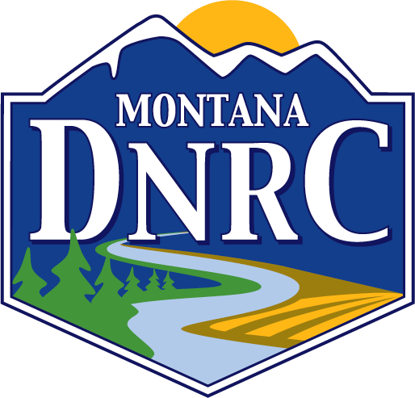
MONTANA FORESTRY PIONEER
NOMINATION FORM

DATE: ___________________

NOMINEE:

NOMINEE’S MAILING ADDRESS:

NOMINEE’S E-Mail Address:

NOMINEE PHONE #:

NOMINATED BY
NOMINATED BY PHONE #____________________ NOMINATED BY EMAIL____________________

NOMINEE’S SIGNIFICANT CONTRIBUTIONS TO MONTANA FORESTRY (please list significant contributions; include other recognitions bestowed on nominee. Attach additional sheets if necessary).

NOMINEE’S BRIEF RESUME (please include education, professional memberships, employers. Attach additional sheets if necessary).

If possible, please include a photograph of the nominee and mail materials to:
Montana DNRC Forestry Division
2705 Spurgin Road
Missoula, Montana 59804

**Note: all materials submitted become property of the DNRC. We are unable to return any documents/photos submitted through the nomination process.**

